The Russian Voices Interview Project: Building Empathy and an Inclusive Classroom Through Video Interviews of Russian Speakers

Appendix:

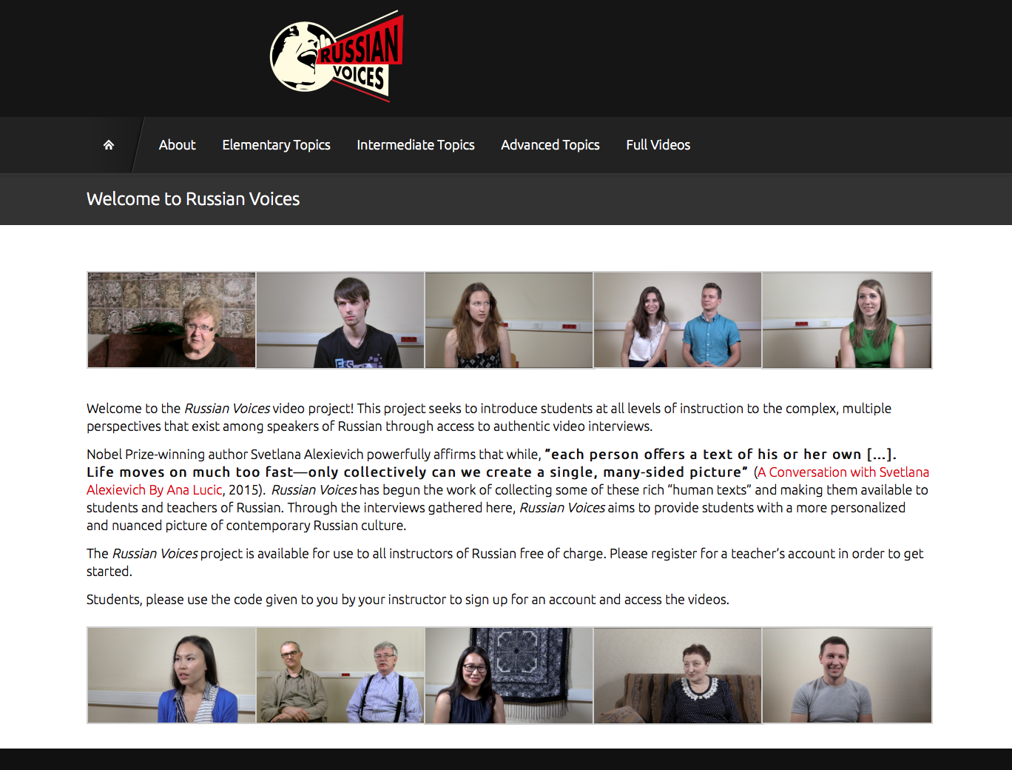
a. Russian-voices.org Home Page

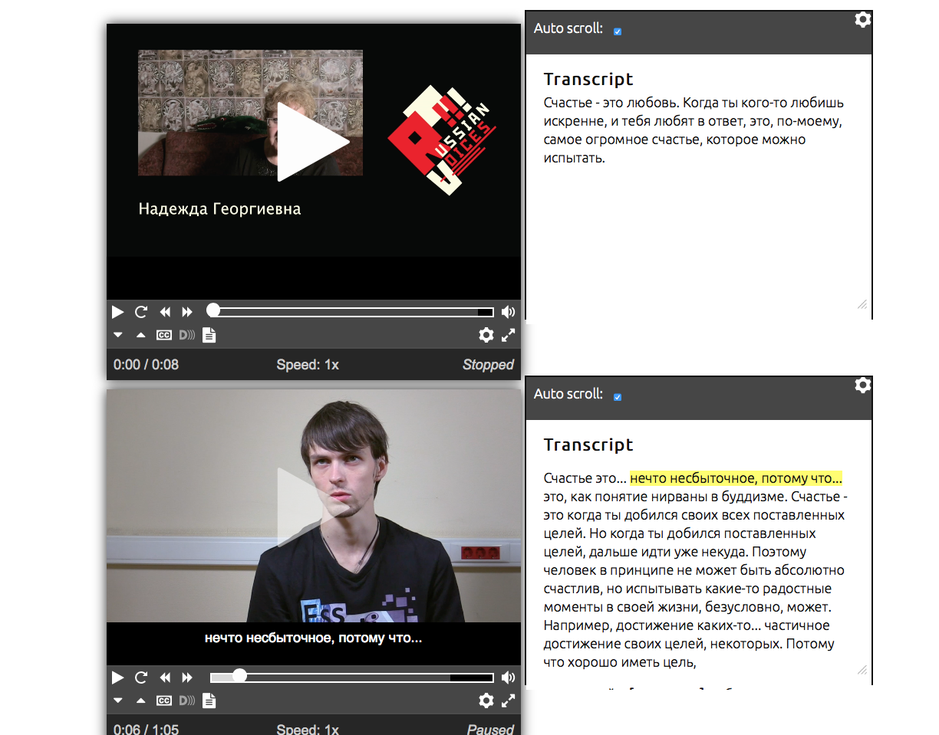
b. Two videos with subtitles, active transcript and slow down capabilities.

